Parking Efficiency Integration

CSUSB Parking

Team Members:

Sally Phang

James Huang

James Small

Leigh-Anna Griswould

***Vision/Description***

Any student who has a class at midday can tell you that finding a parking spot can be difficult at best. What if there was a way to help increase the efficiency of the existing parking lots along with directing students to parking lots with available spots. What we are proposing is a queuing system for each parking lot that keeps track of incoming and outgoing cars and compares those numbers with the number of total parking spots for that lot. These numbers will be updated in real time and will also be displayed at each intersection that leads to a parking lot. There will also be a board at the main intersection that displays the parking statistics for every lot on campus. Utilizing a system such as this can help increase the efficiency of each parking lot while decreasing the need to construct more parking structures. The system can also be used to control the flow of traffic around the campus.

***List of Actors***

* Student Drivers
* Faculty Drivers
* Employee Drivers
* Main Signs
* Structure Signs
* IT Staff

***Glossary***

**Sensor**::=Device underground that can tell when a car drives over it.

**Parking Lot**::= One of many locations on campus where a drive can park, which excludes all Parking Structures.

**Parking Structure**::= One of two locations on campus to park with multiple levels.

**Parking Level**::Parking Structure= Specific locations within a parking structure where drivers can park, separated by different levels within the structure.

**Main Sign**::=Sign at the entrance of campus that informs drivers of parking availability in every lot or structure on campus

**Structure Sign**::= Sign at the entrance of each parking structure that informs drives of parking availability in the parking structure, and on each Parking Level of the Parking Structure

***Risks***

* Vehicle drives out through the entrance or vehicle drives in through an exit. We don’t know if the sensors are smart enough to detect direction and this could mess up our counts.
* Vehicle doesn’t weigh enough to trigger the sensor while entering or exiting

***Use Case Diagram***

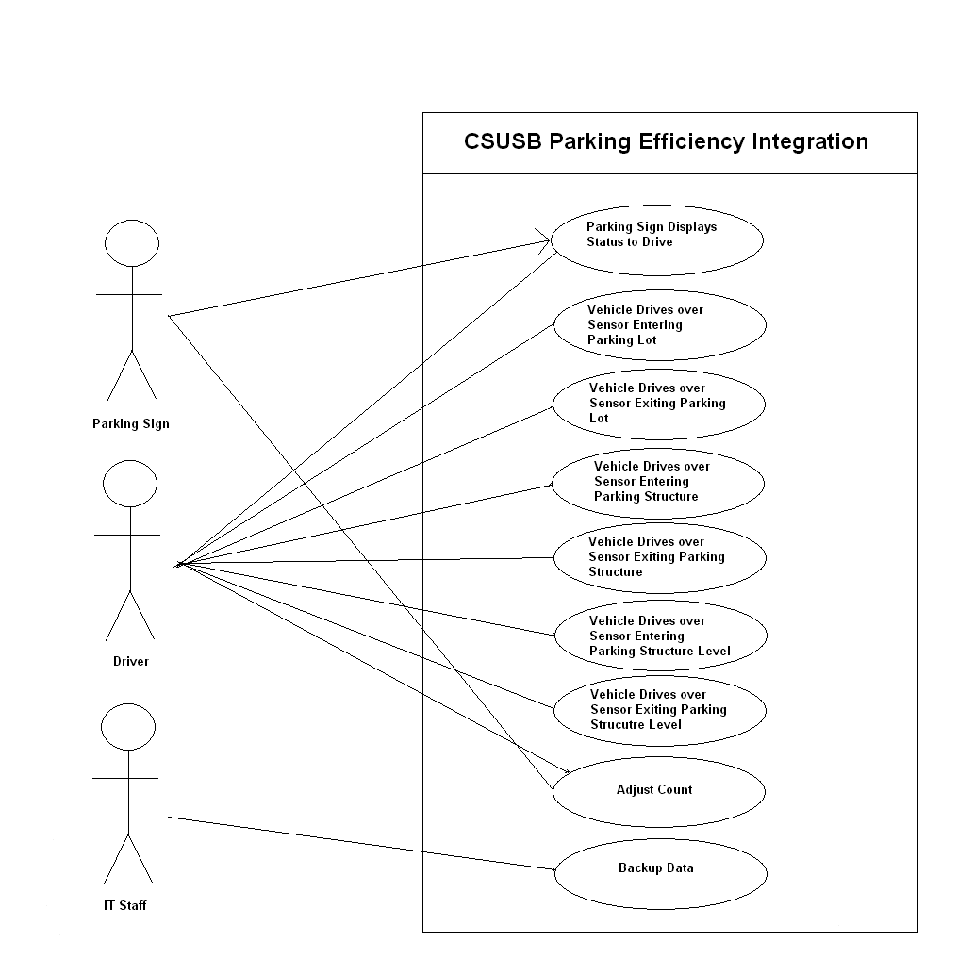

***Fully Dressed Use Cases:***

**Name:** Parking Sign Displays Status to Driver

**Scope:** The system in action.

**Level:** User Notification.

**Primary Actor:** Parking Sign.

**Secondary Actor:** Driver

**Stakeholders and Interests:** Driver, Parking Services, The University.

**Preconditions:** Sign and sensors must display accurate information on the parking lot.

**Post conditions:** Sign reflects that there are spots available so the student enters lot and parks.

**Main Success Scenario:**

1: User looks at sign.

2: Sign reports that there are spots available in this parking area.

3: User enters parking area and parks.

4: Database is updated with new count.

4: Sign Display is modified based on updated count

**Extensions:**

2a: Sign reports that there are no empty spots available.

2aa: User does not enter parking lot.

2ab: User checks a different parking area.

2b: Sign shows parking lot full with no available spots.

2ba: User enters full lot.

2bb: Sign reflects negative number stating that parking area is overflowing.

**Special Requirements:** Parking lot has to be open.

**Frequency of occurrence:** This occurs every time a student tries to enter the parking area.

**Miscellaneous:** Could possible look into using RFID tags to specify which type (handicapped, carpool, etc) of spots are open.

***Casual Use Cases:***

**Name**: Vehicle drives over sensor entering parking lot.

**Main Success Scenario**: A user approaches the entrance to the parking lot. As they drive into the parking lot, the underground sensor identifies the weight as a car. The action is logged and then reflected in the number of available spots displayed on the sign by subtracting 1 from the total available for that particular parking lot.

**Alternate Scenario 1**: If the vehicle doesn’t weight enough to trigger the sensor, the count will be off by 1. The action will not be logged and maintenance will have to be done to adjust the count to the correct total.

**Alternate Scenario 2**: If the vehicle drives over a sensor that is broken, the action is not logged and the number of available spots being displayed will be incorrect. This problem will remain until maintenance has been completed to fix the issue.

**Alternate Scenario 3**: **:** If the vehicle drives out of a parking lot without using a road, the action is not logged and the number of available spots displayed will be incorrect. This problem will remain until maintenance has been completed to fix the issue.

**Name**: Vehicle drives over sensor entering leaving lot.

**Main Success Scenario**: When the user is finished using the parking lot, they will drive out of the parking space and proceed to leave the parking lot. The user will drive over the sensor at the parking lot exit to leave the parking lot. The action is logged and then reflected in the number of available spots displayed on the sign by adding 1 from the total available for that particular parking structure.

**Alternate Scenario 1**: If the vehicle doesn’t weight enough to trigger the sensor, the count will be off by 1. The action will not be logged and maintenance will have to be done to adjust the count to the correct total.

**Alternate Scenario 2**: If the vehicle drives over a sensor that is broken, the action is not logged and the number of available spots being displayed will be incorrect. This problem will remain until maintenance has been completed to fix the issue.

**Alternate Scenario 3**: **:** If the vehicle drives out of a parking lot without using a road, the action is not logged and the number of available spots displayed will be incorrect. This problem will remain until maintenance has been completed to fix the issue.

***Brief Use Cases:***

**Name:** Adjust Count

**Description:** After a vehicle drives over a sensor while entering or exiting a parking area, the count for that particular parking area is updated in the database and on the signs based on the update count.

**Name:** Backup Data

**Description:** The database containing the current parking counts and system software is backed up to ensure fast recovery in case of a disaster.

**Name:** Vehicle Drives over sensor entering Parking Structure

**Description:** A vehicle drives over the parking sensor to enter the parking structure. The action is logged and then reflected in the number of available spots displayed on the sign by subtracting 1 from the total available for that particular parking structure.

**Name:** Vehicle Drives over sensor exiting Parking Structure

**Description:** A vehicle drives over the parking sensor to exit the parking structure. The action is logged and then reflected in the number of available spots displayed on the sign by adding 1 from the total available for that particular parking structure.

**Name:** Vehicle Drives over sensor entering Parking Structure Level

**Description:** A vehicle drives over the parking sensor to enter the parking structure level. The action is logged and then reflected in the number of available spots displayed on the sign by subtracting 1 from the total available for that particular parking structure level.

**Name:** Vehicle Drives over sensor exiting Parking Structure Level

**Description:** A vehicle drives over the parking sensor to exit the parking structure. The action is logged and then reflected in the number of available spots displayed on the sign by adding 1 from the total available for that particular parking structure level.

***Domain Model***

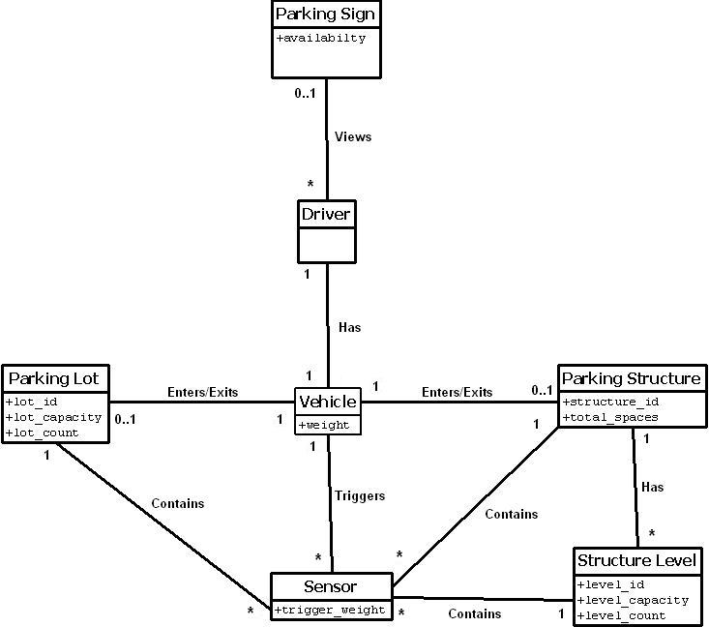

**SSD For Vehicle Entering Parking Lot**

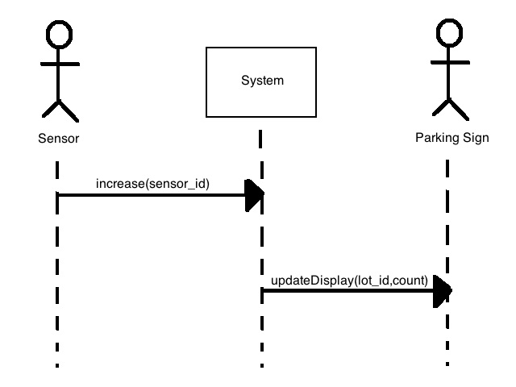

**Logical Architecture**

